There are a number of problems in creating a fuzzy controller which can not be easily solved analytically. For example, to push the ball forward, the robot needs to be able to constantly adjust it's speed and direction so that it does not loose the ball.

Ball
Direction???

Robot

It is not easy to decide how to do this, so we used a fuzzy controller to solve the problem. The price that we pay for this is that more development time is needed to 'train' the controller to behave appropriately.

The controller classifies quantaties in to categories with a certain fuzzy probability.

For example a ball distance can be classified as beeing a large distance away (LP), a moderate distance away (P), or close (Z). So distance is a member of the set {LP, P, Z}

Since these sets are fuzzy, a distance can have a certain probability of bellonging to a particular set.
This is calculated from some arbitrary probability distribution which we can tweak as part of the training proccess.
Ie: given a distance D
Pr(LP|D) = a value calculate from the probability distribution.

The success of using a fuzzy controller is highly dependent on how well we can train it. For this reason, we tried to make the fuzzy controller as general as reasonable. Our controller preforms a general classification for two inputs (A and B). (For example, goal angle and ball angle).
Fuzzy Controller Constructor
The descision matrix is a lookup table used to map inputs to an output using mandani's method (the values in the descision matrix can be altered as part of the training proccess).
Input A's membership function
Input B's membership function
Descision Matrix
Output membership function
Fuzzy Contoller

Note that the fuzzy controller constructor expects FUNCTIONS as inputs (we use function currying to do this). The advantage of this is that it allows the user to define their own custom membership functions. This gave us greater flexibility in the training proccess. To furthur speed up the training proccess we created function generators. Ie: function which we could used to easily create our membership functions. For example, to create a membership function that looks like the spike below, spike = fuzzyMember(h, w, d);
where h: height w: width d:center point
y = spike(x)
% Spike
% y ^
% |
% |
% |
% |
% | 0
% | / | \
% | / | \
% | / |h \
% | / | \
% |-----------0-----X-----0---------------->
% |- w| -| x
% |
% |
% d

Now that we have created a fuzzy controller function for our particular purpose, we can reuse it.
Fuzzy Controller
Input A
Input B
Output

The fuzzy classifier for chasing the ball works in two stages. First, the robot looks at the image of the ball and estimates the distance using an exponential model which we fit from experimental data.
The robot uses this distance figure to classify the ball distance into one of three possible fuzzy values (Large distance, moderate distance, close). The robot constructs a fuzzy controller based on this estimate. There are three coresponding fuzzy classifiers which can result from this process.
The difference is in the descision matrix which is used.

The second step is to input the estimated angle to the ball and angle to the goal into the fuzzy controller. The centroid computed from the controller is then used to update the wheel rotation.

Angle Membership function

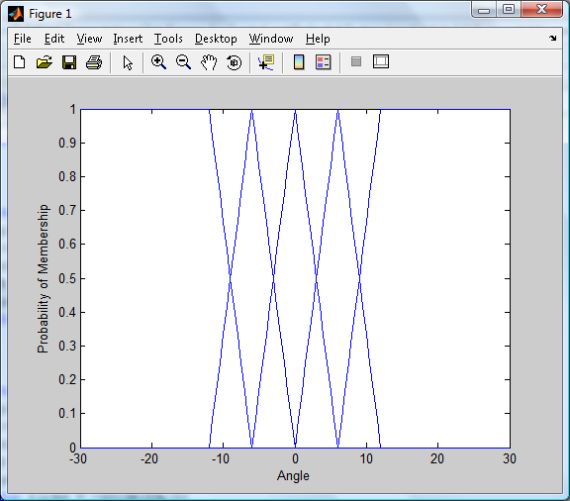
These membership functions are used for both goal distance and ball distance.

Output membership function

for example:
Using a membership function called largeP (for when the ball is a large positive distance away from the robot), a goal angle of 2 and a ball angle of 7, a centroid is calculated.

largeP(2, 7)

ans =

-8.4994
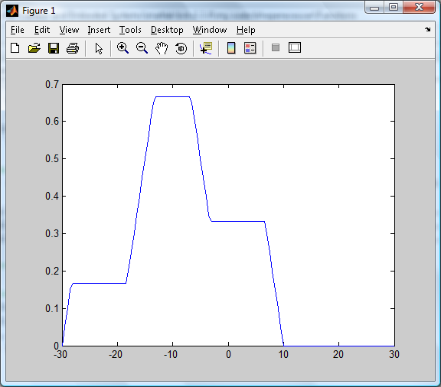
The output is the calculated as the centroid of the above graph.

Descision plane for large distances shown from a few different perspectives.

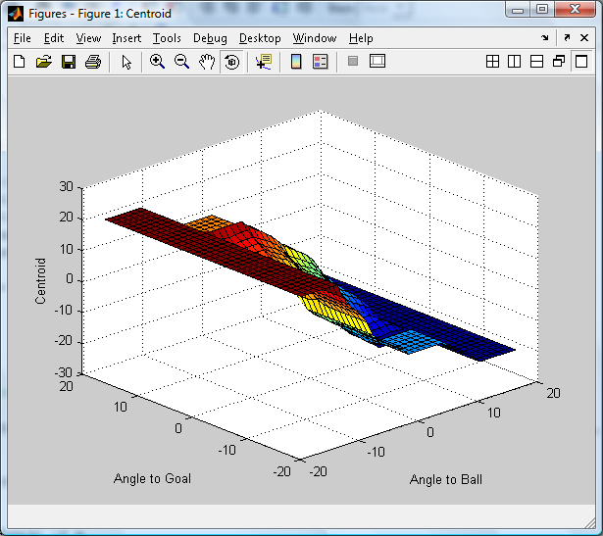

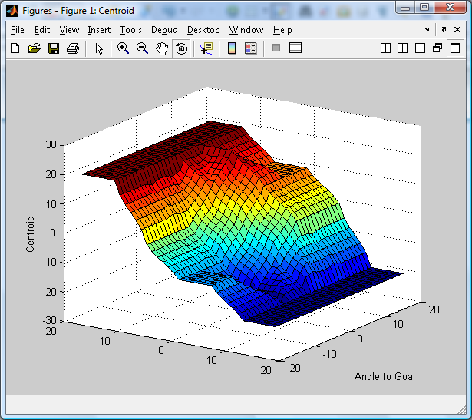
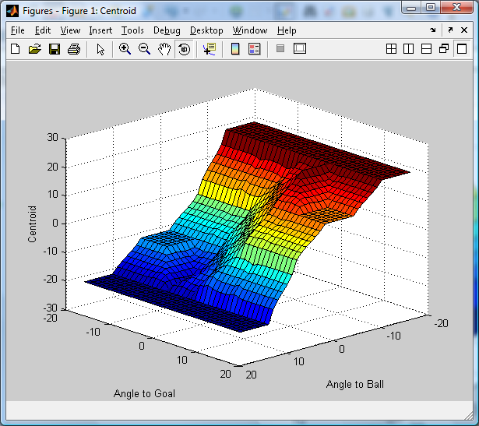
Descision plane for positive distances

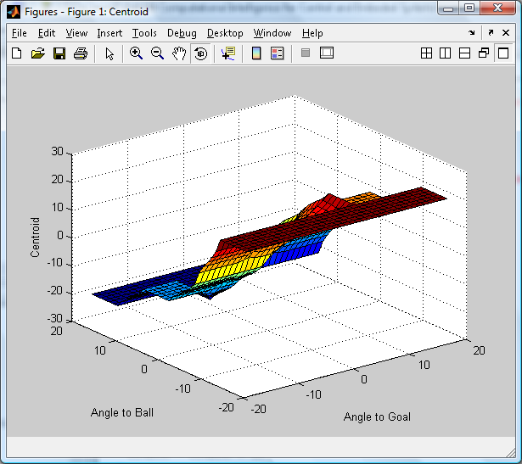

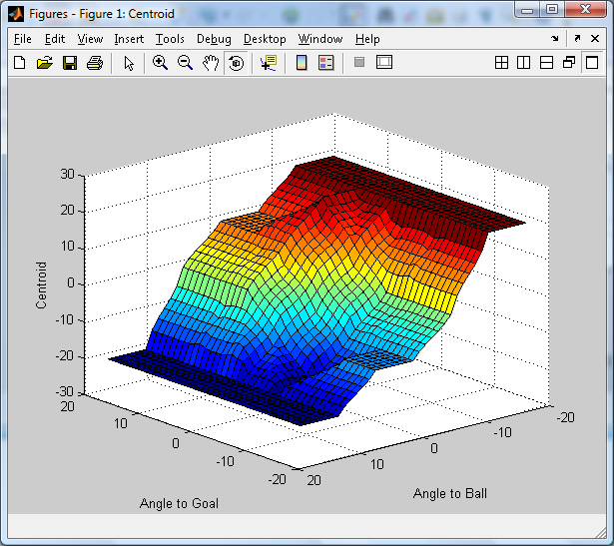
Descision plane for small, near zero distances.
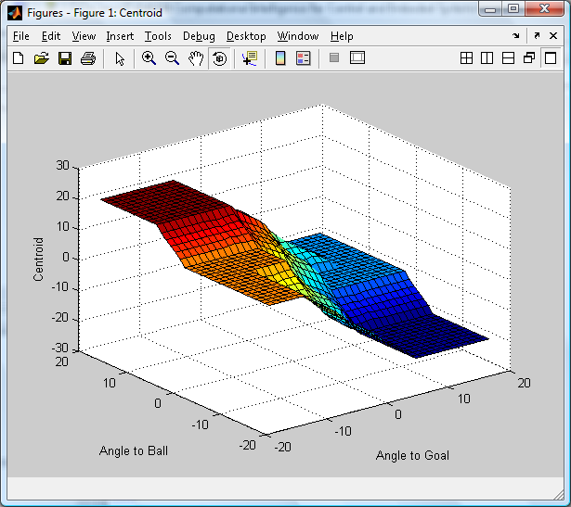

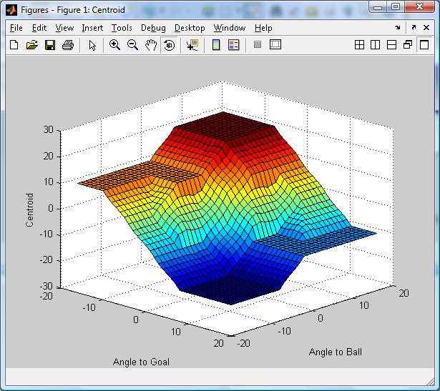
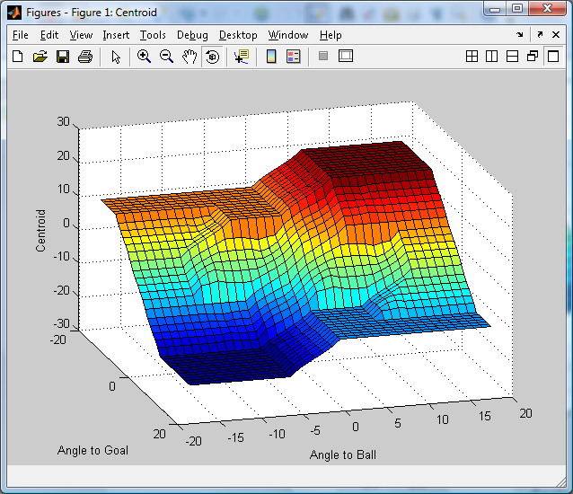

A fuzzy controller is usefull for modelling such tasks as pushing the ball.
However, we don't want to give too much responsibility to the one controller or it will become to difficult to train it. For this reason we have divided the task of scoring a goal into three states.

- Active Scan
When the robot can not find the ball it actively seeks out the ball.

- Chase
When the robot finds where the ball is, it heads towards the ball. The robot will attempt to approach the ball from a side which is opposite the goal.

- Dribble
When the robot gets near the ball, it travells around the ball to the side opposite the goal. It then uses a fuzzy controller to get the ball in the goal.

This can be modelled by a finite statemachine.

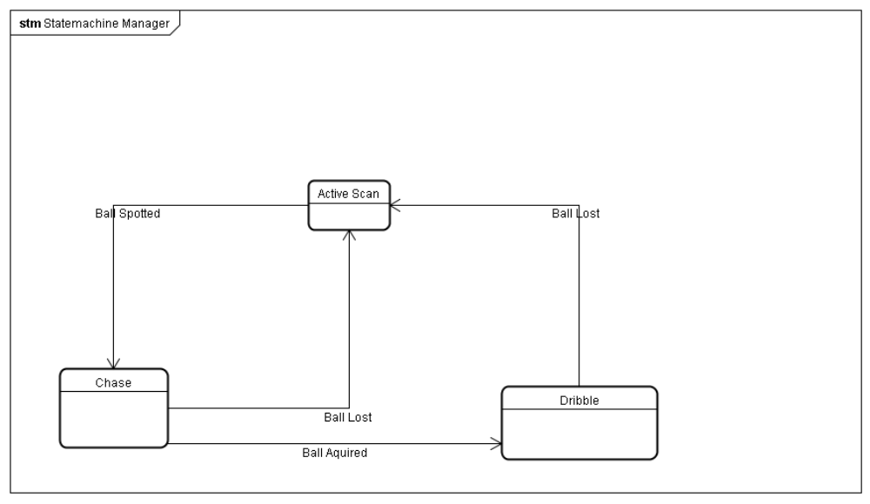
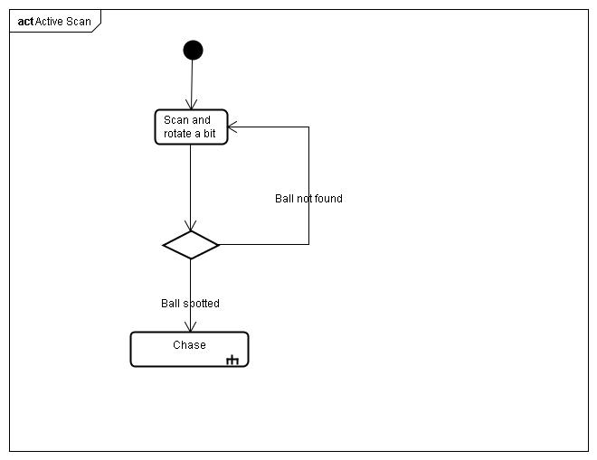

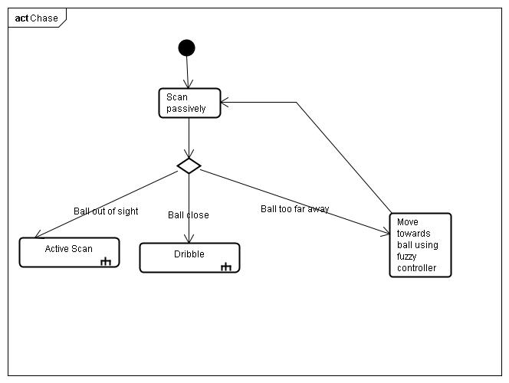

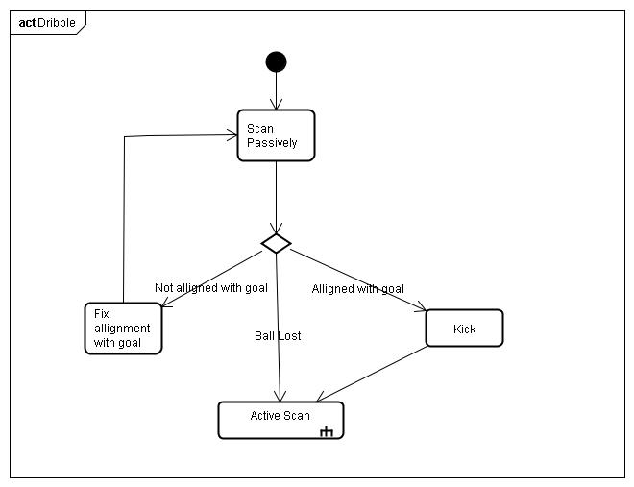

Old version of design
